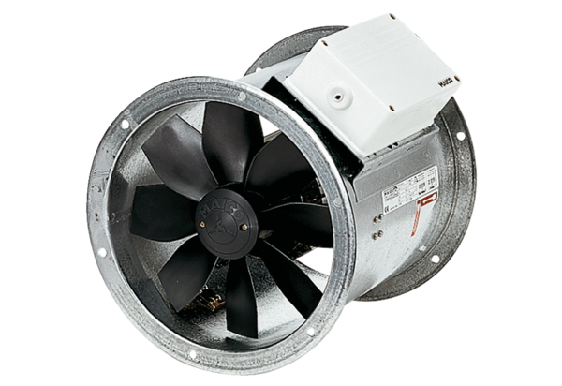Axial duct fan EZR 25/4 DPacking unit: 1 pieceRange: C
Article number: 0086.0487Manufacturer: MAICO

