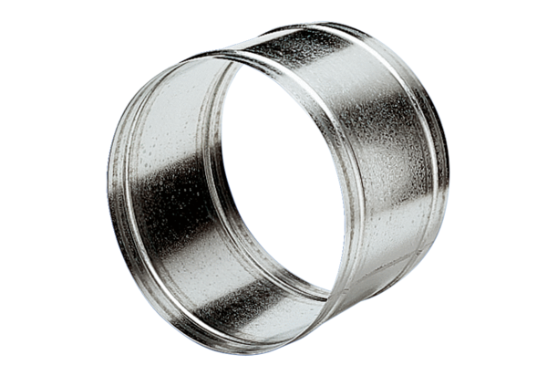Extension sleeve VH 45Packing unit: 1 pieceRange: C
Article number: 0055.0036Manufacturer: MAICO

