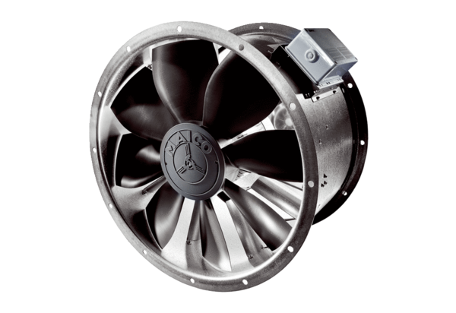Axial duct fan DZL 50/84 BPacking unit: 1 pieceRange: C
Article number: 0086.0099Manufacturer: MAICO

