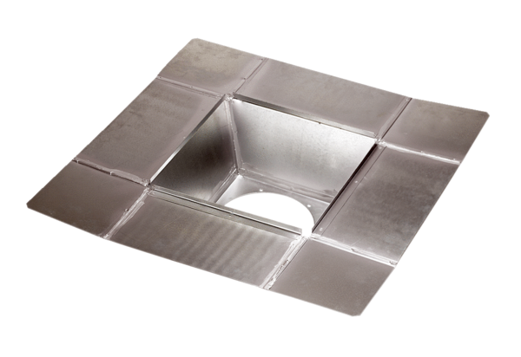Intermediate socket SZ 50Packing unit: 1 pieceRange: C
Article number: 0092.0293Manufacturer: MAICO

