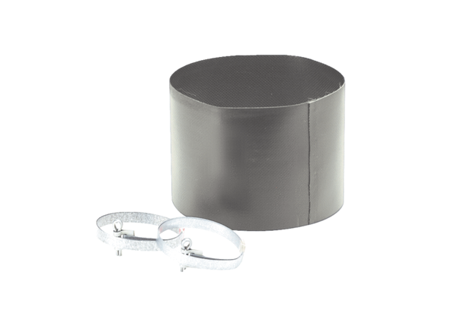Flexible cuff ELM 10Packing unit: 1 pieceRange: C
Article number: 0092.0121Manufacturer: MAICO

