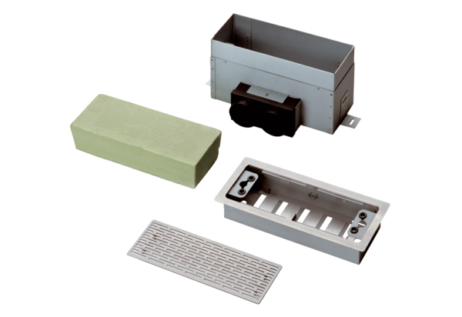Floor / wall outlet MF-FBWA 63Packing unit: 1 pieceRange: K
Article number: 0152.0057Manufacturer: MAICO

