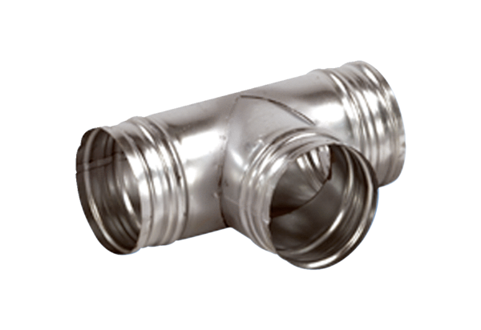90° branch AB 160-200Packing unit: 1 pieceRange: K
Article number: 0055.0373Manufacturer: MAICO

