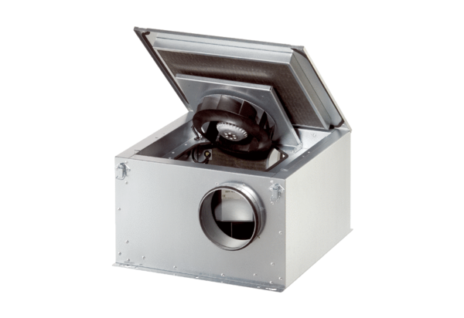Sound-insulated ventilation box ESR 16-2 SPacking unit: 1 pieceRange: C
Article number: 0080.0618Manufacturer: MAICO

