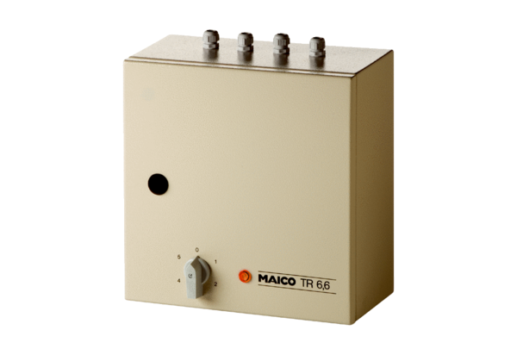5-step transformer TR 6,6Packing unit: 1 pieceRange: C
Article number: 0157.0384Manufacturer: MAICO

