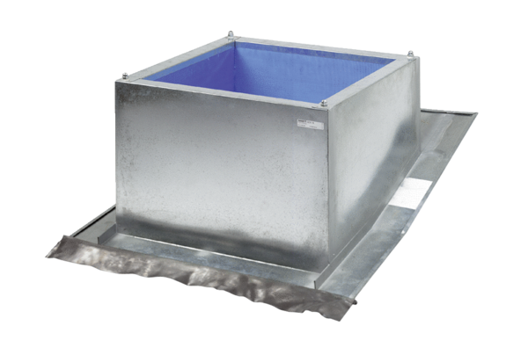Roof socket for pitched roofs SDS 45Packing unit: 1 pieceRange: C
Article number: 0093.0980Manufacturer: MAICO

