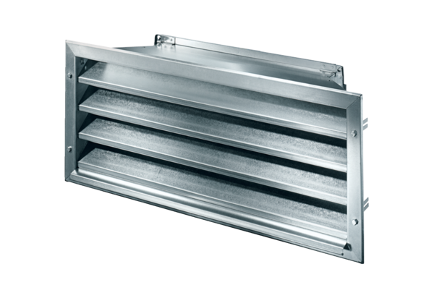External grille LZP-R 25Packing unit: 1 pieceRange: D
Article number: 0151.0382Manufacturer: MAICO

