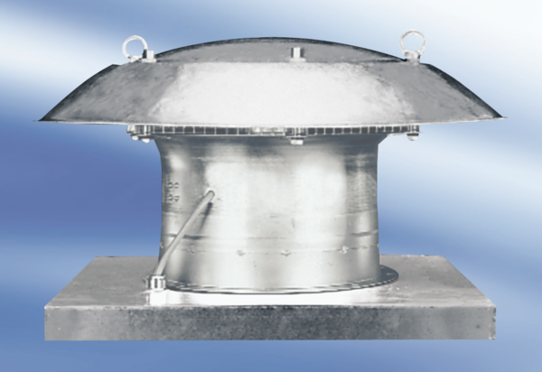Axial roof fan DZD 40/64 APacking unit: 1 pieceRange:
Article number: 0087.0445Manufacturer: MAICO

