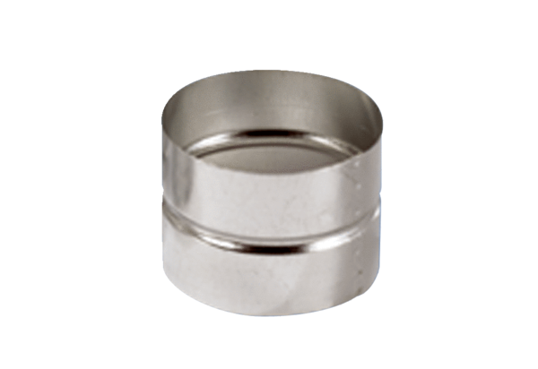Adaptor plug connector SVF 150Packing unit: 1 pieceRange: K
Article number: 0055.0052Manufacturer: MAICO

