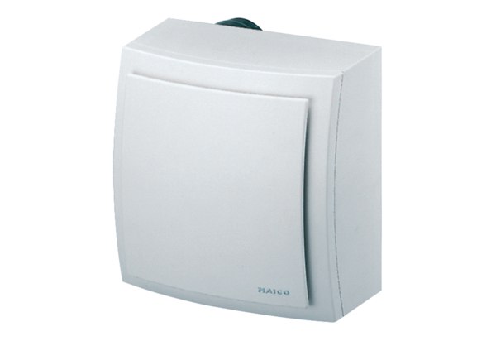Surface-mounted fan, fire protection ER-APB 100 HPacking unit: 1 pieceRange: B
Article number: 0084.0180Manufacturer: MAICO

