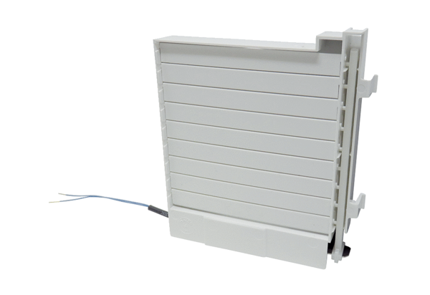Shutter frame KR ECA 100 iproRange: A
Article number: E059.2007.9101Manufacturer: MAICO

