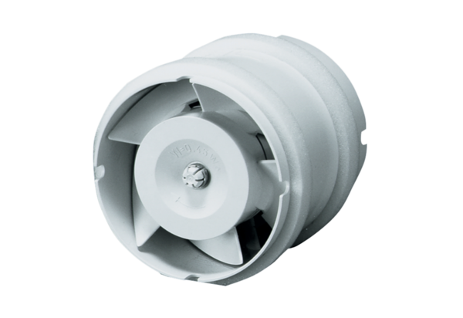Duct-mounted fan ECA 15/4 EPacking unit: 1 pieceRange: A
Article number: 0080.0991Manufacturer: MAICO

