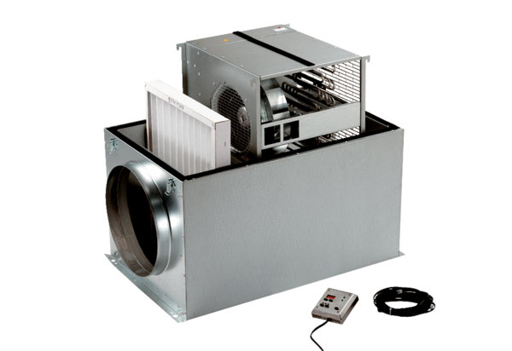Compact box ECR 25Packing unit: 1 pieceRange: C
Article number: 0080.0563Manufacturer: MAICO

