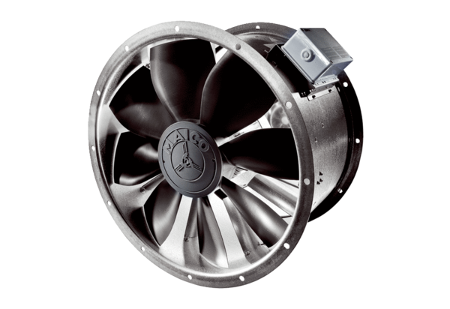Axial duct fan DZL 35/42 BPacking unit: 1 pieceRange: C
Article number: 0086.0096Manufacturer: MAICO

