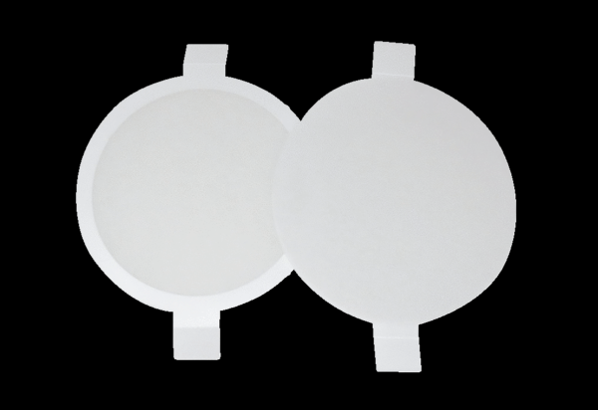Air filter, replacement PPF E1Packing unit: 2 x G3Range: K
Article number: 0093.0082Manufacturer: MAICO

