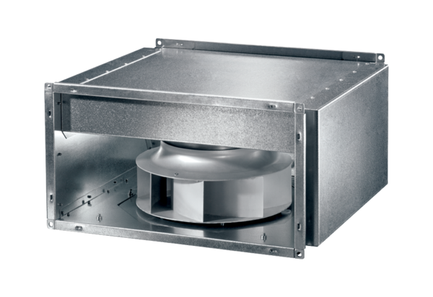Sound-insulated channel fan DSK 50 ECPacking unit: 1 pieceRange: E
Article number: 0086.0809Manufacturer: MAICO

