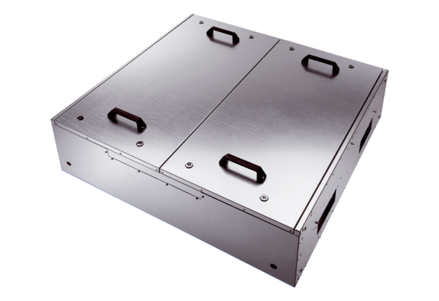Sound-insulated Flatbox for supply air with two air filters KFR 9030-FPacking unit: 1 pieceRange: K
Article number: 0080.0881Manufacturer: MAICO

