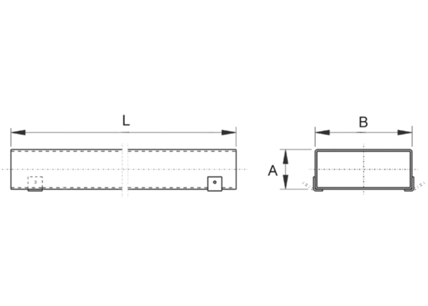Flat channel FK80/150/1500Packing unit: 1 pieceRange: K
Article number: 0055.0547Manufacturer: MAICO

