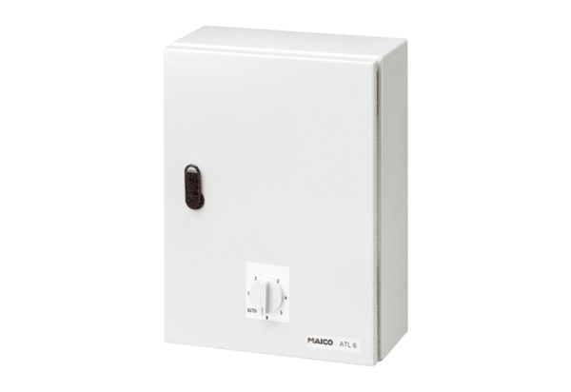Temperature control system, power module ATL 2,5Packing unit: 1 pieceRange: C
Article number: 0157.0757Manufacturer: MAICO

