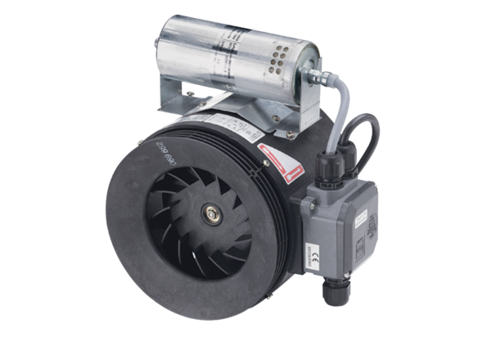Semi-centrifugal duct fan ERM 18 Ex tPacking unit: 1 pieceRange: C
Article number: 0080.0466Manufacturer: MAICO

