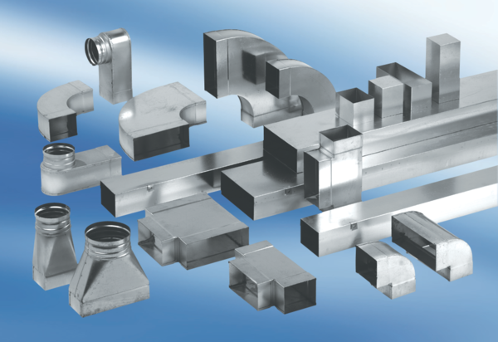Intermediate piece, symmetric USSN70/170/100Packing unit: 1 pieceRange: K
Article number: 0055.0680Manufacturer: MAICO

