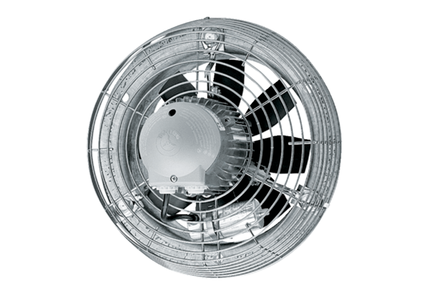Axial wall fan EZS 40/6 BPacking unit: 1 pieceRange: C
Article number: 0094.0006Manufacturer: MAICO

