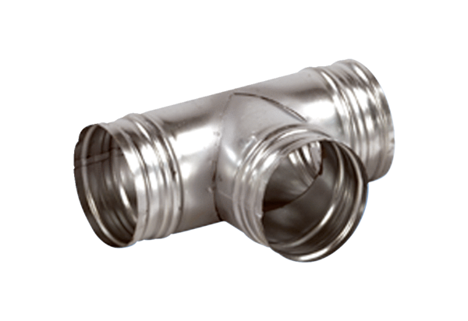90° branch AB 125-160Packing unit: 1 pieceRange: K
Article number: 0055.0357Manufacturer: MAICO

