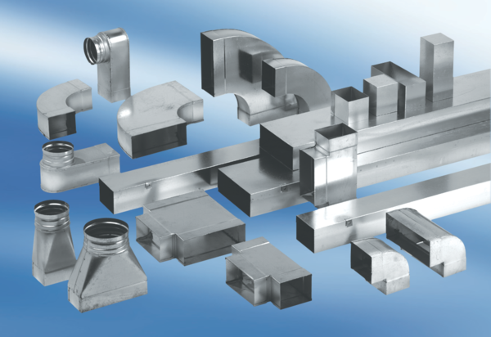90° channel elbows, long, vertical KB90LV/80/100Packing unit: 1 pieceRange: K
Article number: 0055.0579Manufacturer: MAICO

