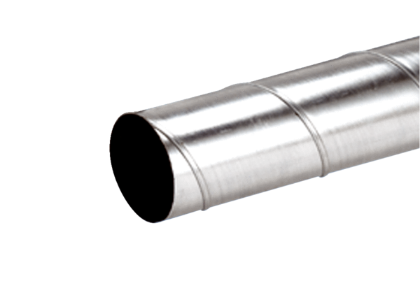Folded spiral-seams duct WFR 200Packing unit: 1 pieceRange: K
Article number: 0055.0081Manufacturer: MAICO

