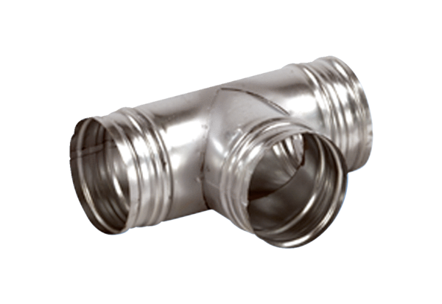90° branch AB 125-125Packing unit: 1 pieceRange: K
Article number: 0055.0355Manufacturer: MAICO

