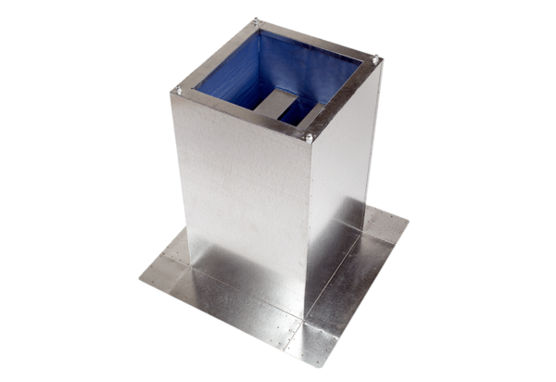Socket sound absorber SD 50Packing unit: 1 pieceRange: C
Article number: 0092.0344Manufacturer: MAICO

