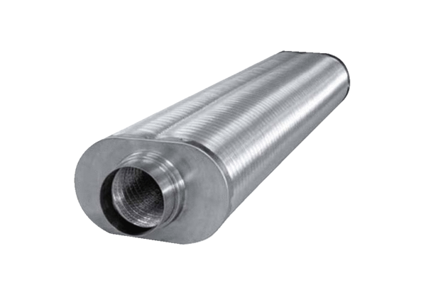Flat oval duct sound absorber RSOF 10/100Packing unit: 1 pieceRange: K
Article number: 0092.0533Manufacturer: MAICO

