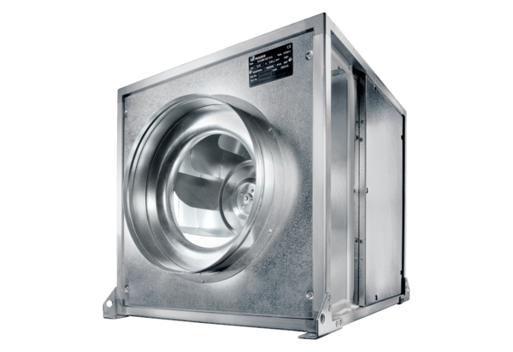Quickbox ESQ 31/4 KPacking unit: 1 pieceRange: C
Article number: 0080.0070Manufacturer: MAICO

