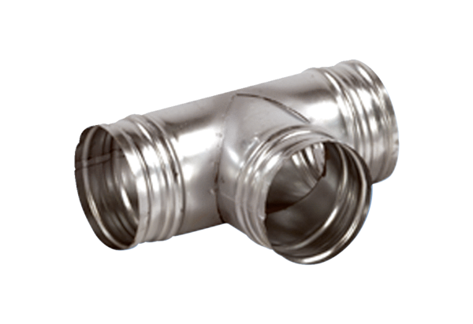90° branch AB 180-125Packing unit: 1 pieceRange: K
Article number: 0055.0376Manufacturer: MAICO

