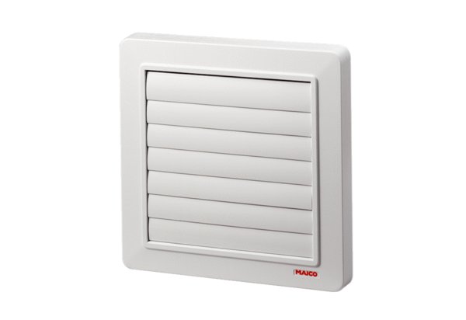Shutter AP 150Packing unit: 1 pieceRange: A
Article number: 0059.0952Manufacturer: MAICO

