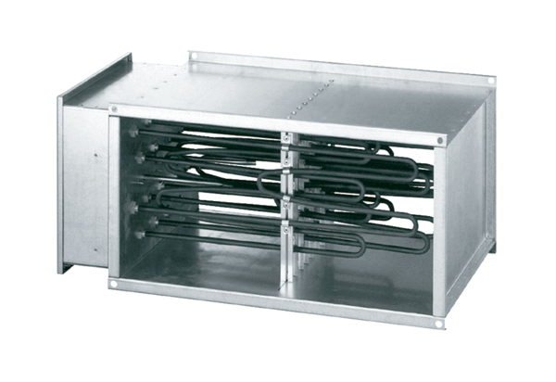Electrical air heater DHP 25-16Packing unit: 1 pieceRange: D
Article number: 0082.0093Manufacturer: MAICO

