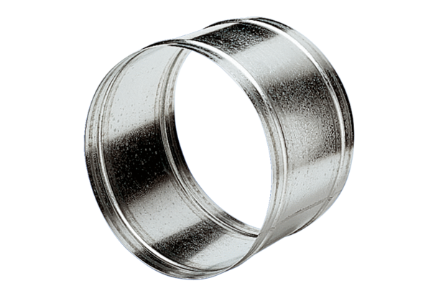Extension sleeve VH 35Packing unit: 1 pieceRange: C
Article number: 0055.0033Manufacturer: MAICO

