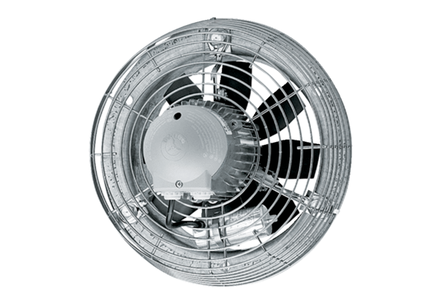Axial wall fan DZS 35/2 BPacking unit: 1 pieceRange: C
Article number: 0094.0060Manufacturer: MAICO

