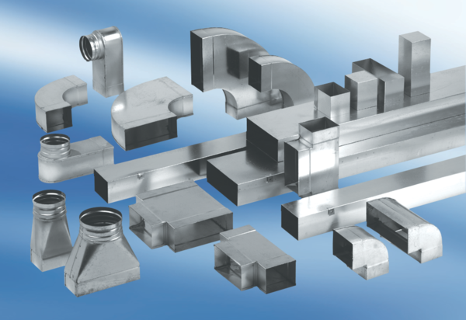90° channel elbows, long, vertical KB90LV/55/110Packing unit: 1 pieceRange: K
Article number: 0055.0576Manufacturer: MAICO

