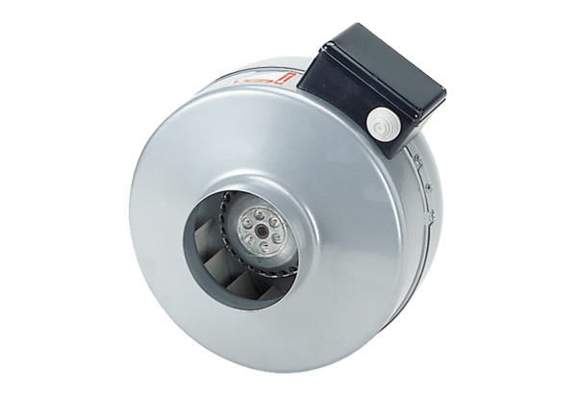Centrifugal duct fan ERR 35/1 SPacking unit: 1 pieceRange: C
Article number: 0080.0871Manufacturer: MAICO

