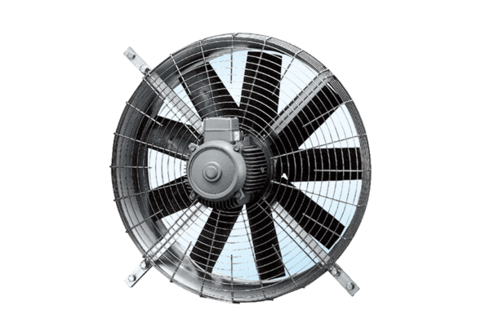Axial wall fan DZQ 80/6Packing unit: 1 pieceRange: C
Article number: 0083.0645Manufacturer: MAICO

