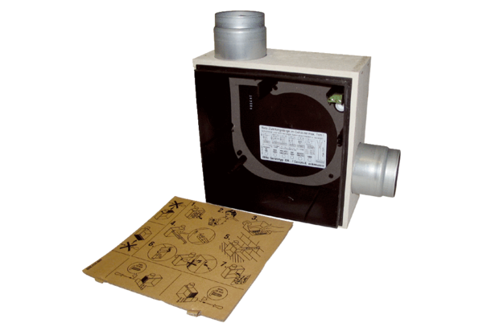Recessed-mounted housing ER - UPB/RPacking unit: 1 pieceRange: B
Article number: 0093.0969Manufacturer: MAICO

