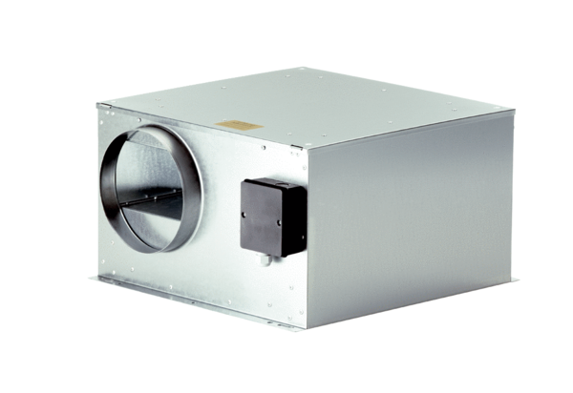Sound-insulated ventilation box ECR-A 12Packing unit: 1 pieceRange: C
Article number: 0080.0565Manufacturer: MAICO

