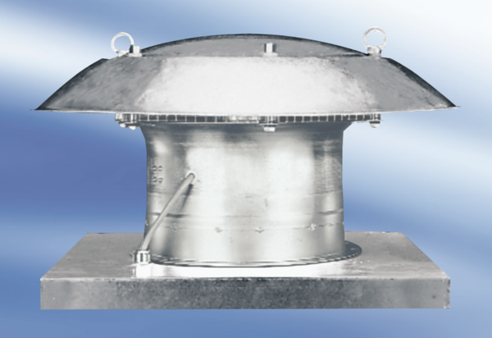Axial roof fan DZD 30/42 APacking unit: 1 pieceRange:
Article number: 0087.0436Manufacturer: MAICO

