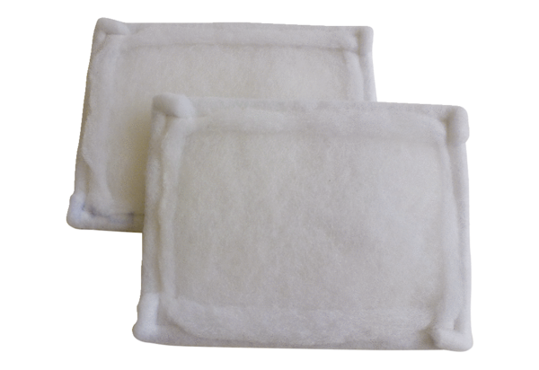Air filter, replacement FE 10-1Packing unit: 2 piecesRange: C
Article number: 0093.1221Manufacturer: MAICO

