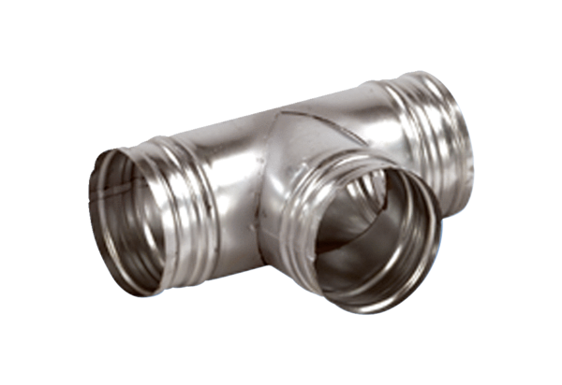90° branch AB 200-180Packing unit: 1 pieceRange: K
Article number: 0055.0386Manufacturer: MAICO

