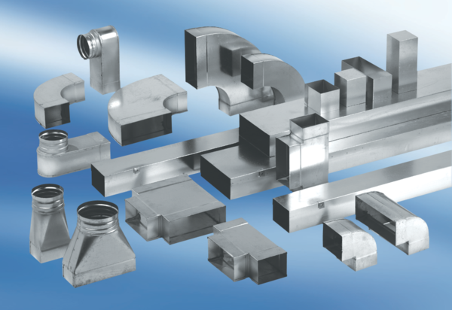90° angle elbow, left-sided asymmetrical WB90ALN55/220/100Packing unit: 1 pieceRange: K
Article number: 0055.0626Manufacturer: MAICO

