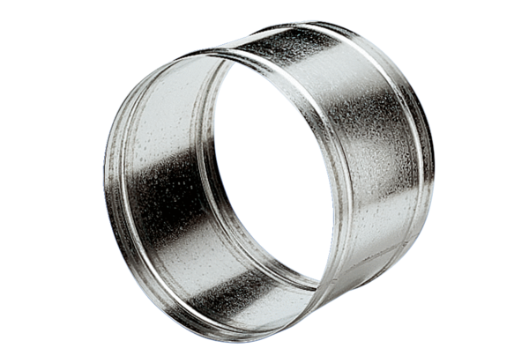Extension sleeve VH 40Packing unit: 1 pieceRange: C
Article number: 0055.0034Manufacturer: MAICO

