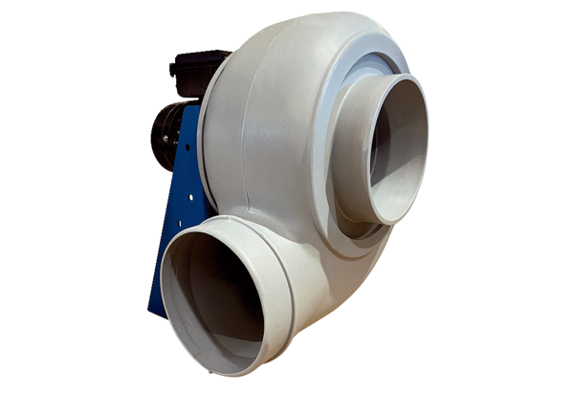Centrifugal blower GRK R 63/6 DPacking unit: 1 pieceRange: C
Article number: 0073.0533Manufacturer: MAICO

