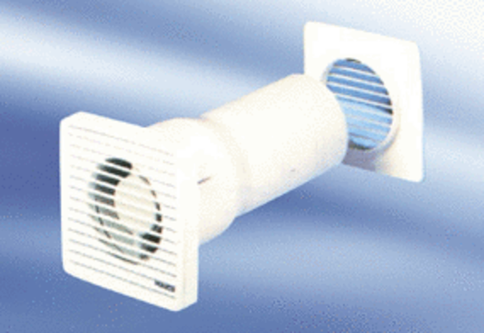Small room fan ECA 10-3 VZPacking unit: 1 pieceRange:
Article number: 080020Manufacturer: MAICO

